Export Roster from Activity Listing into Excel. Remove unneeded columns and then copy/paste the table here.

¨ Introductions / Ice Breaker

Þ Name?

Þ How long have you been with The Mountaineers?

¨ Review map and plan. Distance, elevation. Time. Water Sources. Breaks.

Þ Goals, personal and group.

¨ Volunteer w/ first-aid training/experience to be first-aid leader?

Þ Ask hikers to inform first-aid leader of medical conditions in private

Þ Ask hikers to share w/ group if they have any life-threatening conditions that may arise, location of critical medications

¨ Staying Together, Work Together

Þ Should be able to see 1 person in front and 1 person in back

Þ Wait / Gather at all trail intersections, water crossings, or other hazards

Þ Party Separation procedure. Buddy System.

Þ Safety first. Stay together, turn around together, look out for one another!

¨ Volunteer Sweep. Strong hiker, able to catch up and relay if needed!

¨ Parking Passes / Permits on Display

¨ Hide Valuables

Þ  Car Keys

¨ Break in about 15 minutes for clothing / pack adjustment

¨ My Pace

¨ Speaking Up Early.

Þ Too hot

Þ Hot spots on feet

Þ Pace

Þ Rest

¨ Phones in Airplane Mode. Start tracking. Set Waypoint. Let’s go.

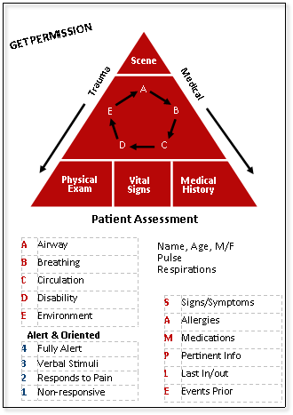

**Other Emergency Response Guidance:**

**Serious Accidents:**

*Definition*:

· Requires evacuation, or assistance back to the trailhead

· Requires hospitalization or treatment by a medical professional, or

· Results in death

*Procedures*:

· Stay calm – take charge of situation, work w/designated first aid person.

· Utilize the entire group; organize and assign individuals to do certain tasks

· Elicit individual expertise (medical, climbing, scrambling).

· Don’t let anyone leave unless you’ve assigned them to go get help, and no one should be solo - your obligation is to the whole group, not just the injured person.

· Be careful that a 2nd accident does not occur.

**Lost Hiker**

· Determine when hiker was last seen.

· Plan a search party – don’t send anyone out alone; nobody should be waiting alone while group searches.

· Designate a time and place to reassemble all search groups

· If hiker is not found contact the local sheriff or park ranger.

***After any rescue initiated, contact the Mountaineers via emergency line: 206-521-6030***



**Seven Steps for First Aid Response**

**Step 1 .** Take Charge of the Situation

**Step 2.** Approach the Patient Safely

**Step 3.** Perform Emergency Rescue and Urgent First Aid.

DO NOT MOVE THE PATIENT AGAIN UNTIL STEP 7!!!!!

**Step 4.** Protect the Patient.

DO NOT MOVE THE PATIENT TO END EXPOSURE TO HEAT, COLD OR WEATHER but build shelter around them.

**Step 5.** Check for Other Injuries

**Step 6.** Plan What to Do

**Step 7.** Carry Out the Plan